**P2 – Explain the different uses of animation**

**Introduction**

In this report, I will explain how different animations is used in different content.

**Advertising**

Animation that is used in advertising by using cartoons. Advertising on TV through adverts is one of the most popular ways of advertising. Companies use computer animations for this to be complete. Most companies use computer animations, because it grabs attention and the user can understand it. An example of where animation is used is the Nike Football advert. It shows real life footballers converted in a cartoon version. Even if the customers do not understand the language, they can visualise the animated advert and understand it. The second advert is the same example. These ‘aliens’ are using promoting the Christmas sale of 2011. They are animated too. Also, it encourages young children to buy the product they would like.

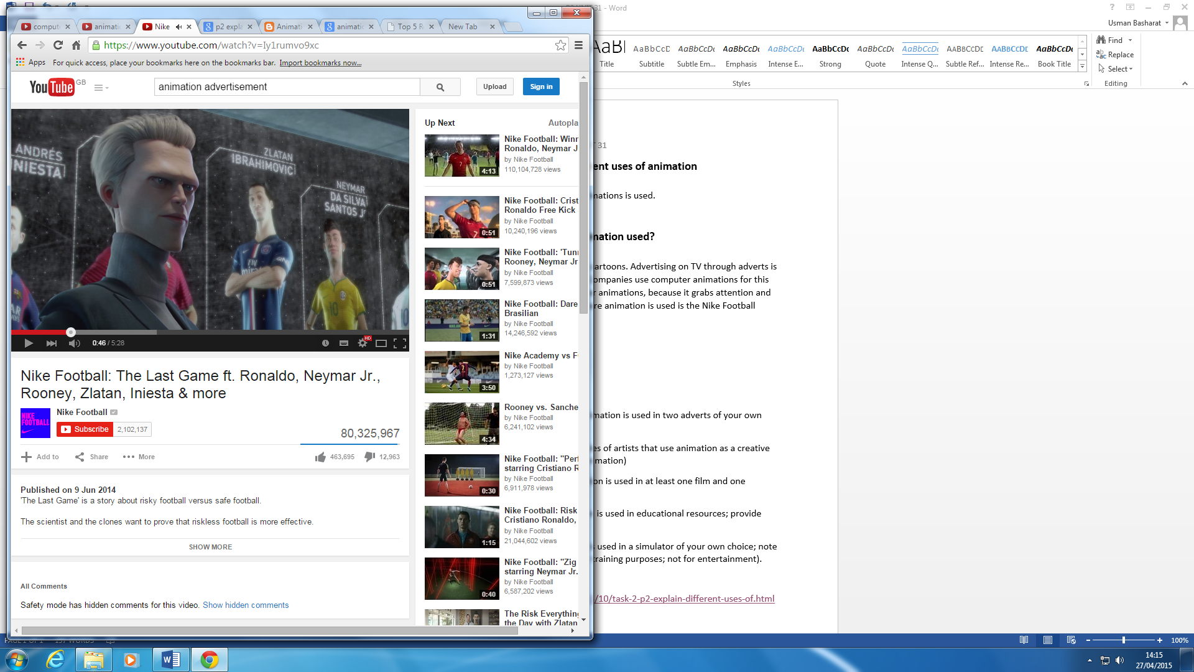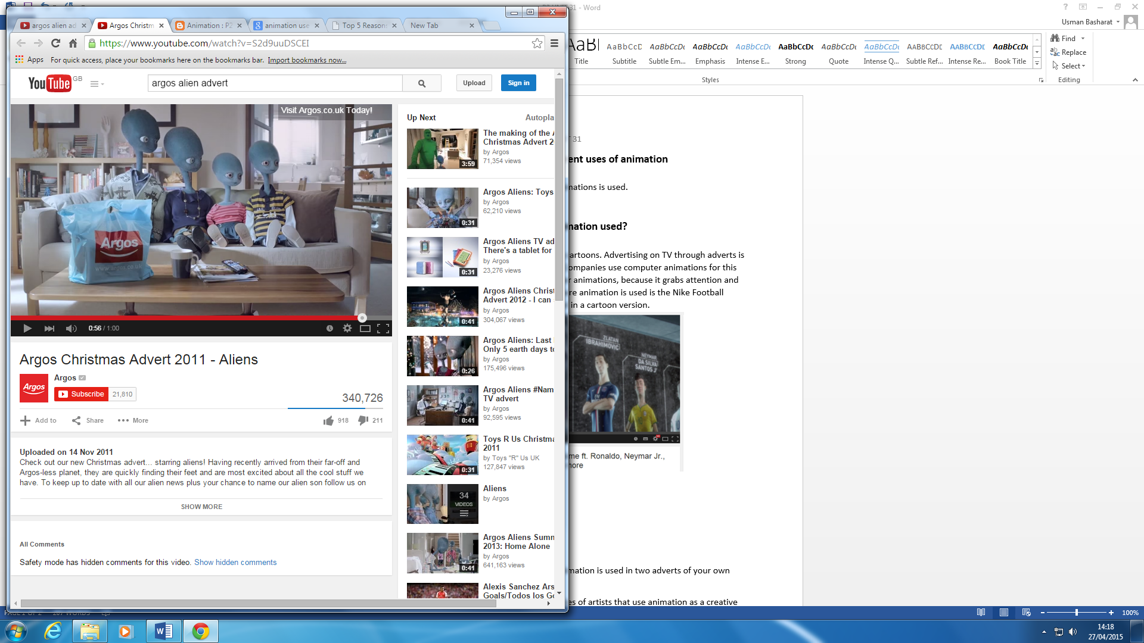

**Creative arts**

### Creative arts animation is used by artists to product creative art. A combination of Adobe Photoshop and skill produces creative art for these people. Graphic Designers use Photoshop to edit images. The Penguins of Madagascar is an example of creative art. They won an award for its creativity. They have used animation by the combination of software and flash within it. It takes a very long time to create a whole movie.

### http://1.bp.blogspot.com/-KyerQQT7uZI/T9Iqz6k9unI/AAAAAAAACi8/dvHmrK-Dg_M/s1600/Nickelodeon-UK-Cast-Of-Nicktoon-The-Penguins-Of-Madagascar-In-Action-Pose-Animation-Animated-Show-Series-New-York-City-Central-Park-Zoo.jpg"The Penguins of Madagascar" Wins 2011-2012 Creative Arts Primetime Emmy Award for 'Outstanding Animated Program'; Ceremony Attended By the Cast of "Victorious"

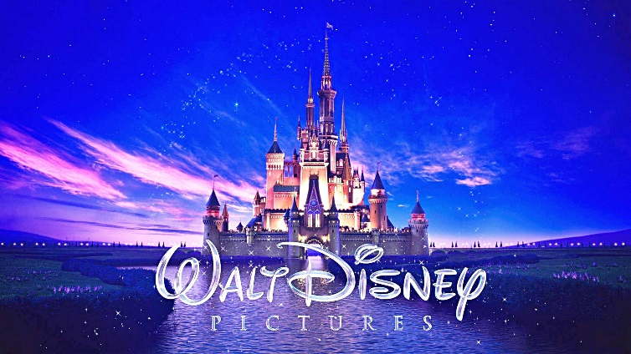**Entertainment**

Entertainment uses animation by companies to directly appeal to a younger audience. Disney films are most popular for entertainment. Disney used frame by frame, but now it is all computerised. It looks better now than they use to look. Nowadays, animation can be used within a real life movie. For example, Toy Story is an entertaining animated movie. A computer game entertaining users could be Sports Head.

[](http://www.google.co.uk/url?sa=i&rct=j&q=&esrc=s&source=images&cd=&cad=rja&uact=8&ved=0CAcQjRw&url=http%3A%2F%2Fen.wikipedia.org%2Fwiki%2FAdobe_Flash&ei=vm0_VbzzLMKqaYG2gZgK&bvm=bv.91665533,d.d2s&psig=AFQjCNFb5Jz8orAB_BBiXjadm5moJaDxkQ&ust=1430306620935647)**Education**

Animation that is used in education is learning how to animate. Some enthusiastic students will end up taking computer animations course and learning how to animate throughout the course. Technology allows users to learn how to animate like companies do. Adobe Flash is an example of an educational software that users learn to animate.

**Simulation**

Simulation can be games that is used on different platforms. Animation is used within these games to create/make real life. A popular choice is GTA 5. This is a game that you can explore and live. You can get cars and apartments with missions to complete too. The picture below shows a GTA apartment.

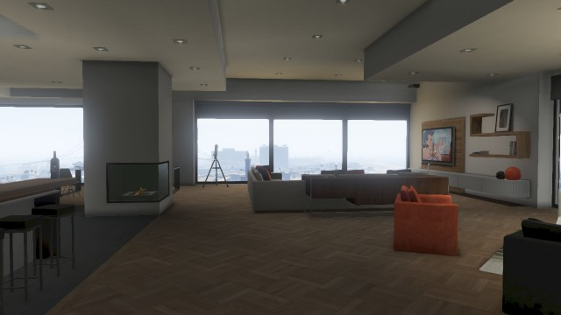

**Reference**

* <http://unit31-ryandenton.blogspot.co.uk/2013/10/task-2-p2-explain-different-uses-of.html>
* <https://prezi.com/2kyiddvmypia/unit-31-p2-explain-different-uses-of/>